Maths square puzzle 2
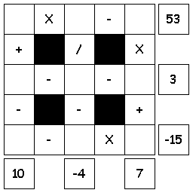
Try to fill in the missing numbers.
Use the numbers 1 through 9 to complete the equations.
Each number is only used once.
Each row is a math equation. Work from left to right.
Each column is a math equation. Work from top to bottom.

Maths square puzzle 2 Solution
